**Test Assignment for Data Science Intern**

**Happymonk Technology – SADHVI ANUNAYA R**

**PROBLEM STATEMENT:**

The purpose of the task is to classify the target variable accurately. Using neural network the classification model should be built. The neural network must consist of 1-hidden layer that adapts to the best activation function for the bank note dataset.

**DATA SET:**

The dataset used is data_banknote. It contains 1372 instances in the data set , and the number of variables is 5.

**VISUALIZATION:**

*Boxplot Distributions*

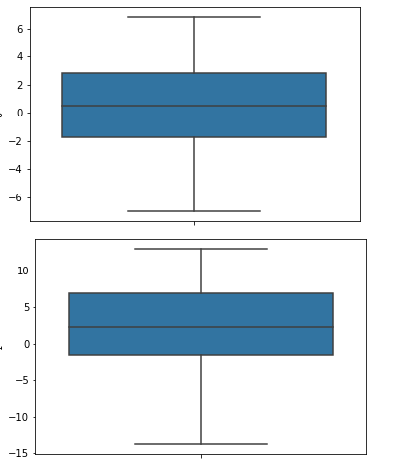

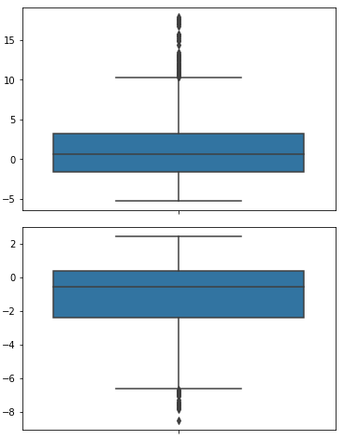

**Dataset:**

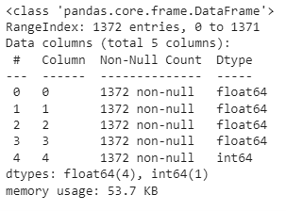

**IMPLEMENTATION:**

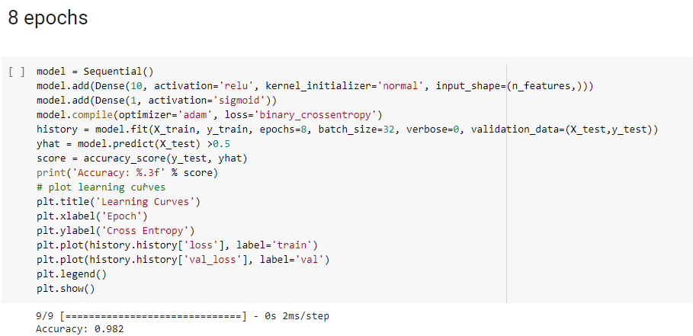

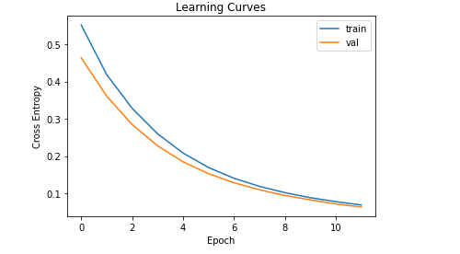

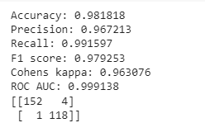

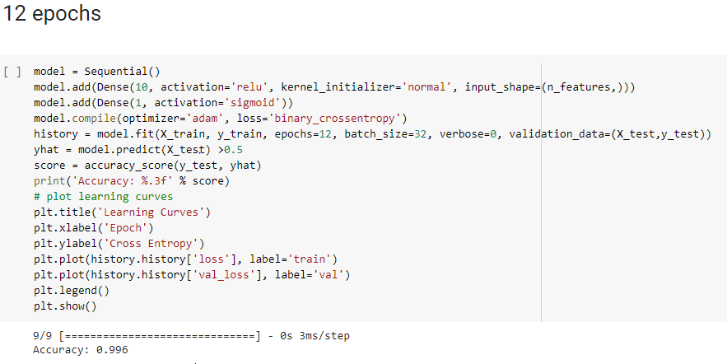

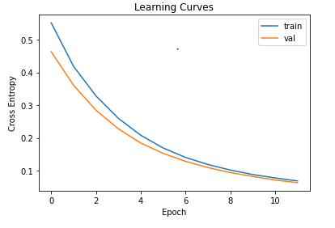

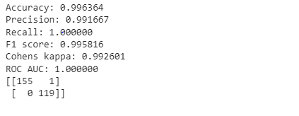

**With 12 epochs the accuracy is more over the data.**

**Conclusion:**

When the epoch value is increased there is an increase in the accuracy of the data.